Assignment report

Student: Denisenko Sofiia 狄苏菲
Student id: 1820249051
Course: Data Warehouse and Data Mining
Experiment Topic: Data cleaning

Task Description
Please dowload the dataset "Telco customer churn (11.1.3+)" and make the following problems cleaned.
1. Missing value
2. not Missing but Wrong value
3.not Missing, not Wrong, but unusable value.

Dataset

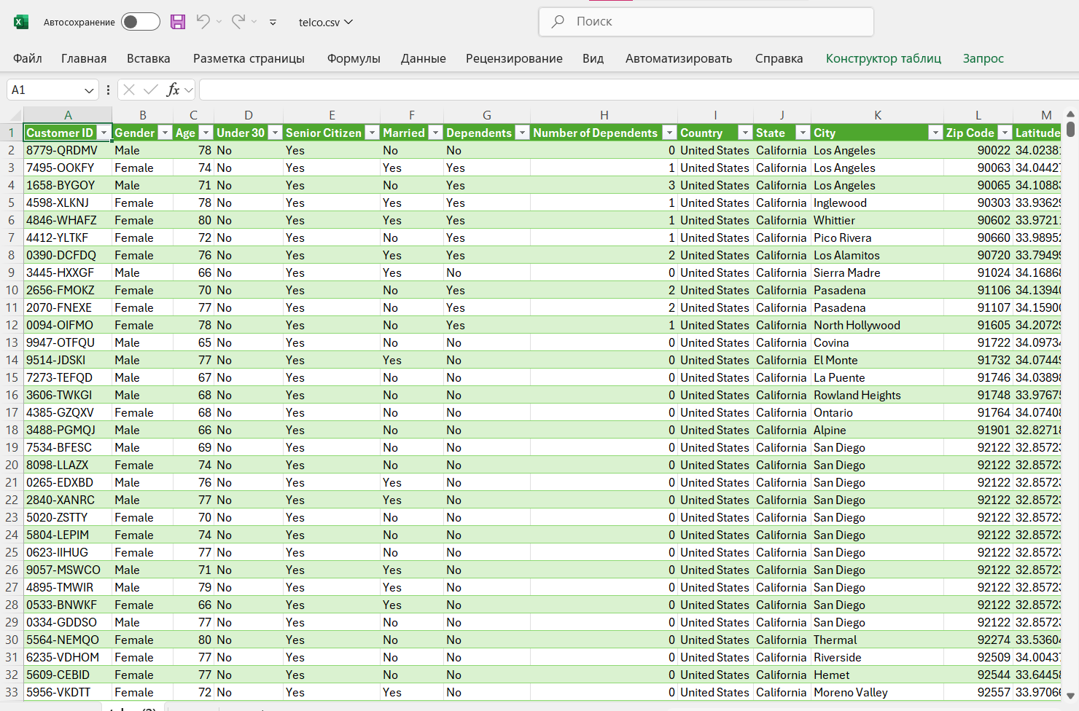

Code
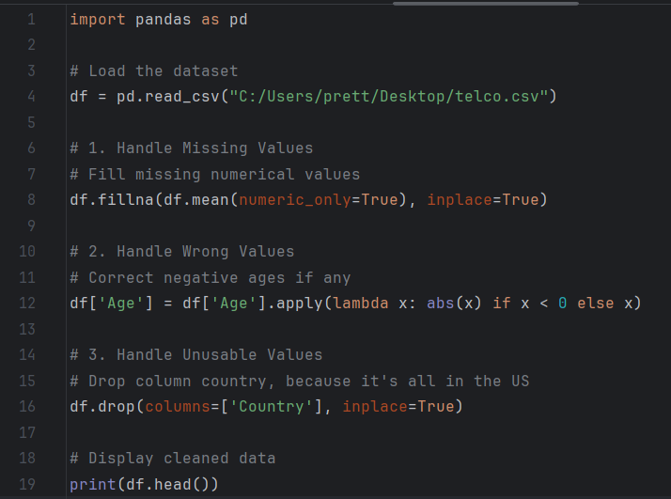
For missing values (task #1) numerical columns are filled with their mean.
For wrong values (task #2), I find negative ages and correct them using abs() finction.
For unusable values (task #3), the “Country” column is dropped as all people have the Country US.
Result
